**It’s...**

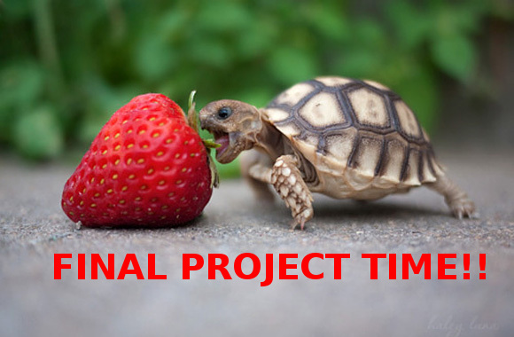

**Goal:**

Together with your team, you will complete a Python project

**Requirements:**

* *Theme*: your project must get your players to think about environment
* Define a list of features you want to implement
* Use skills learned in last two weeks
* Input/output via keyboard/mouse listeners

You can think about adding advanced features, including, for example:

* Edge detection
* Photo Editing
* Creating multiple levels
* Artificial intelligence (play against the computer)
* Advanced animations

Your team can invent an entirely unique project, or make a new and clever version of a familiar project - for example using your MiniProject or the instructor examples to get started. But there must be something that makes your project original, different, and connected to the theme.

**Timeline: Your team has about 10 hours, in total - no time to waste!**

|  |  |
| --- | --- |
| **Date:** | **To Do:** |
| Sun 12 Aug. | * As a team complete the project proposal, describing: (~1 hour)   + theme - environment   + structure (what objects do, how they interact, how user controls components, etc.)   + what the major pieces of code are, and how the work will be shared across the team (there are four of you!) * **Pitch project idea to instructor or TA** - *must get approval before continuing* (10 min.) * Start coding (remaining time, ~2 hours) |
| Mon 13 Aug. | * Morning check-in: What are the things you plan on doing today? What do you need help with? * **Did you accomplish the things you set out to do? If not, why? Must show an instructor or TA what your team has accomplished by the end of the day!** * Have minimal working version complete. |
| Tues 14 Aug. | * FACEBOOK! |
| Wed 15 Aug. | * Morning check-in: What are the things you plan on doing today? What do you need help with? * What advanced features can you add to the project? * **Did you accomplish the things you set out to do? If not, why? Must show an instructor or TA what your team has accomplished by the end of the day!** |
| Thurs 16 Aug. | * **SHOWCASE**: Every group will be shared for everyone to use in a final celebration at the closer of the MEET summer - try out as many projects as you are able. |

|  |
| --- |
| **Must be finished by:** end of MEET day (16:30), Wednesday, 15 August |

**Final Project Proposal:**

**Project Title:** ____________Garbage Run________________________________

**Member Names:** _________Niv_________________ _____________Mai__________

_________Dalia_________________ _____________Aboud____________

**How it involves Environment:** write at least two sentences about how the project makes the user think about the environment

Garbage run is a computer game with a similar function as Dino run except when the runner hits a piece of trash, it must answer an enviormentaly based question to continue

**Features:** (list features such as user controls, graphics, animations, objects/moving-parts, etc. and include a short description)

|  |  |
| --- | --- |
| *Example: swimming fish* | *Turtle of a fish that swims around the screen randomly* |
| Running guy | Turtle of a guy who runs moves across the screen |
| Garbage | A trash.gif that the runner must jump over |
| Q and A | A multiple choice question that you answer when you hit a piece of trash. |
| Up and Down controls | Controls for your runner to jump and duck |
| Smog | Smog made by the toxic enviorment that the runner must duck under |
|  |  |

**Work Distribution:** (list the group members and their **specific** tasks - not just ‘coding’)

|  |  |
| --- | --- |
| Aboud | Q and A |
| Dalia | Runner/controls |
| Mai | Smog |
| Niv | Trash |

**Milestones:** (outline what **specific** tasks you expect to accomplish by each day)

|  |  |
| --- | --- |
| Sunday  Aug 12 | -finish proposal and get approval from staff  Make moving course |
| Monday  Aug 13 | Runner/controls |
| Wednesday  Aug 15 | Smog and trash  Q and A |
| Thursday  Aug 16 | -showcase finished project! |

Final Project Rubric

|  |  |  |  |  |
| --- | --- | --- | --- | --- |
|  | Outstanding | Impressive | Acceptable | Needs work |
| **Creativity** - unique features implemented, innovative ways to connect to the theme, etc. |  |  |  |  |
| **Code Quality** - clear structure, easy-to-follow comments, good design, good variable names |  |  |  |  |
| **Theme** - how well does the project showcase the theme and send a message to the user |  |  |  |  |
| **Teamwork** - how fair was the distribution of work/input of members, positive attitude! |  |  |  |  |
| **FUN!** - how much does the user enjoy the project |  |  |  |  |